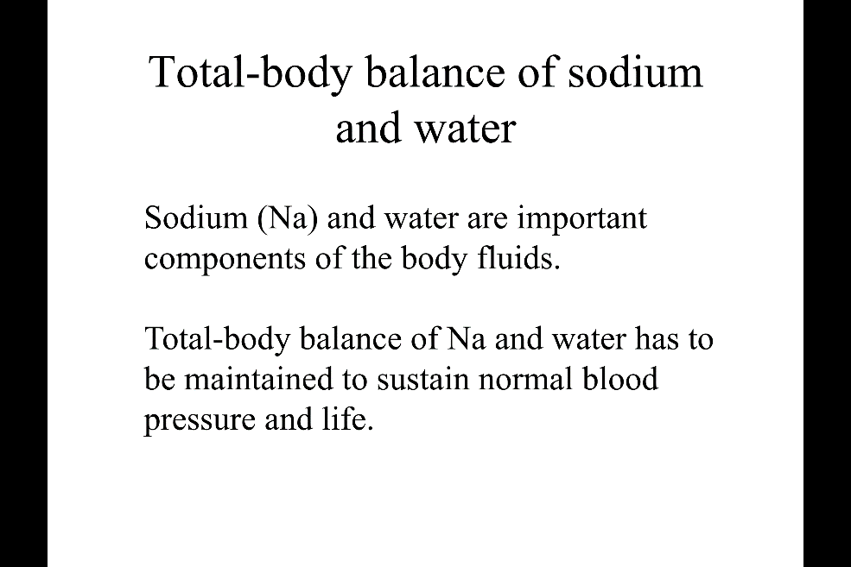
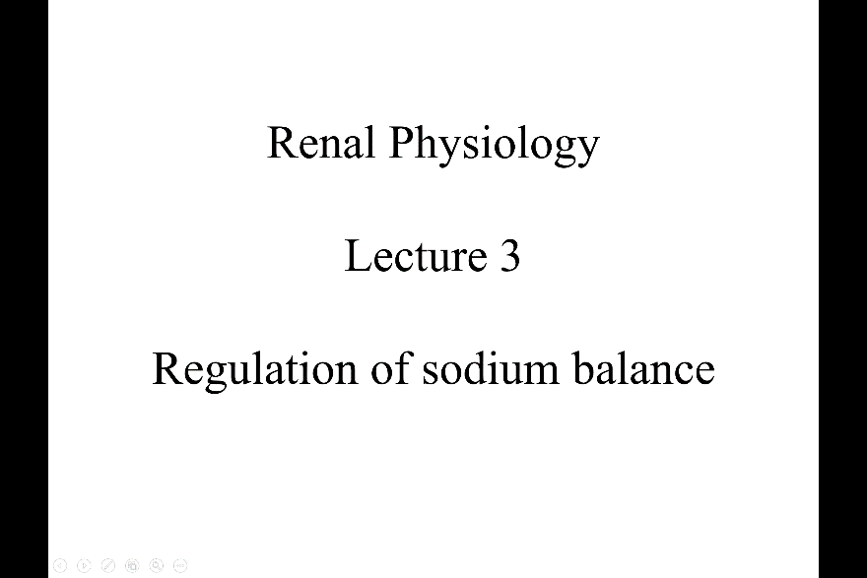
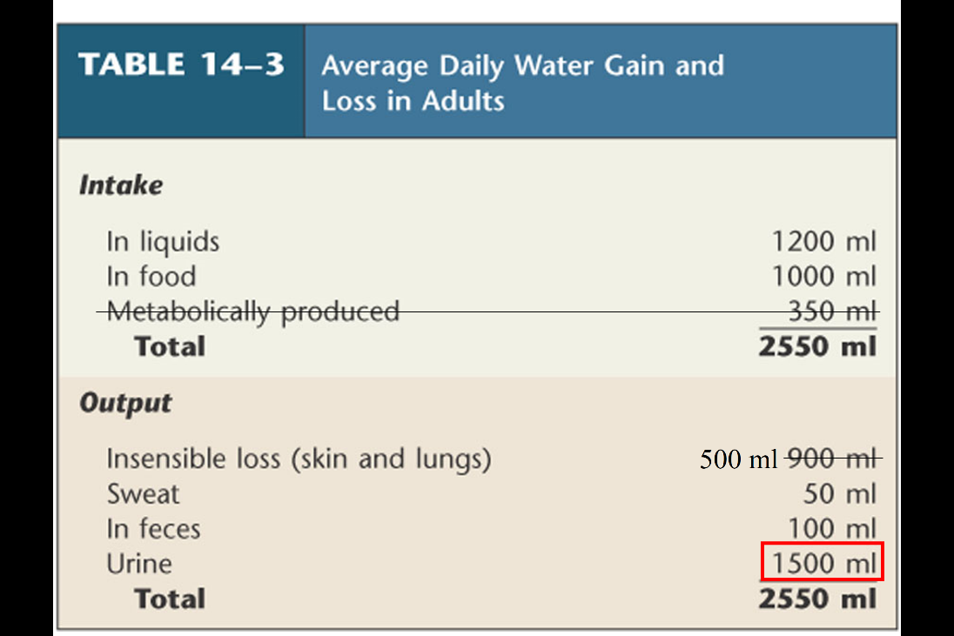
Na+ is maintain in a proper amount (regulated)

The intake of water:
- Intake is from eat + liquid (varies between ppl)
- Metabolically produce, water is a by product in the body
Output:
- Insensible loss water evaporation (a lot)
- Sweat, feces (varies between types: ex, diarrhea is a large amount of lost)
- Quantitively, the most important output is urine (1.5~2 L). this is the only regulatable output of water.
- (Insensible loss, sweat, feces can’t be control. It depends on the environment, physical condition, health. Urine output can be controlled by the kidney depends on the input)
If look at the in and out, it balances. Kidney adjust the output of water to maintain the balance.
- Usually subtract metabolically produce to insensible loss, so when deal with patient can decide how much fluid will give to the patient. (we count the insensible, even if can’t see)
- Output of sodium is dominantly to urine (this is the regulatable component) kidney adapt to the input
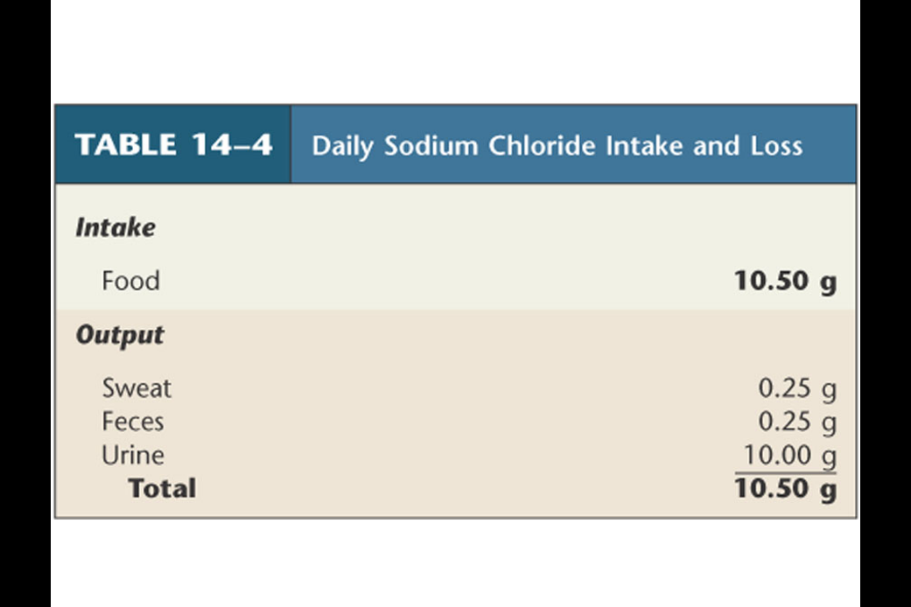

Sodium balance
- Intake is absolutely from what you eat (10.5g --- NaCl)
- Similarly to water, Output of sodium is dominantly to urine(10g, almost all output) (this is the regulatable component of Na+ output) kidney adapt to the input
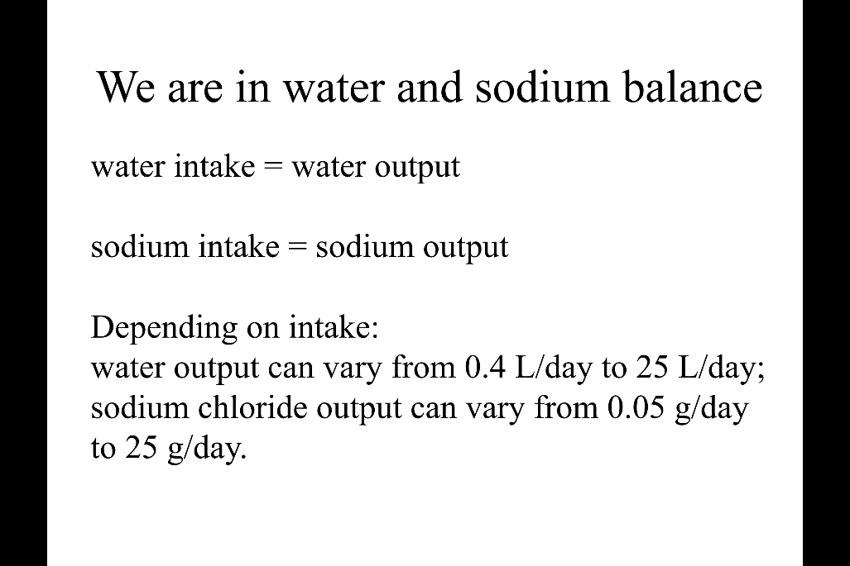
Water intake has to match water input. Sodium intake have to match sodium output.
- Depend on the intake the urine output has to change quite a bit
- When don’t drink much, sweat lot, diarrhea ……. Urine can go down to less than 0.5 L per day, and very concentrated urine (dark color)
- When intake bear, urine increase -----25L maximum.
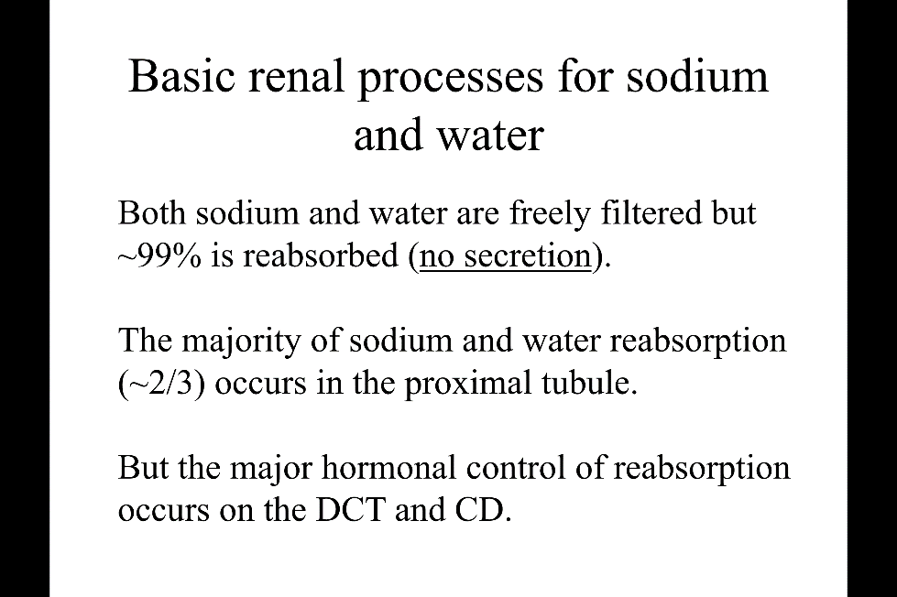
- NaCl output can also verify a lot: when not intake NaCl , output can goes down to 0. (big salt eater can go up to 25g/day)
- Urine have a large capacity to balance out what comes in.
Basic renal process
- Both Na, water are freely filtrated at the glomerulus. Water and Sodium are tiny, so are freely filtered.
- Almost all of them are reabsorb (99%), remember that water and sodium is not secreted in the tubule. only 2 process contribute: filtration and reabsorption
- We see the huge range of the output of Na+/H2o, but say 99% are reabsorb. What happens?
- Think of the degree of filtration in both substance --- GFR is 180L per day, even if reabsorb 99% of water. In total there is still 1,8 L of urine. If change the rate by 1%, it doubles to 3.6 L urine of output.
- Just adjust the reabsorb percentage can highly change the final urine output
- Same idea for the sodium, by adjusting the reabsorption rate a bit can change the finial excretion amount.
- This is the first principle.
- Second principle:
- For both Na+, water. Majority of reabsorption occur the in proximal tubule (2/3 of filtration is reabsorbed)-----quantitatively important.
- The final fine tuning is in distal, collecting duct
- So first part, quantity is important but not much regulated of fine tuning
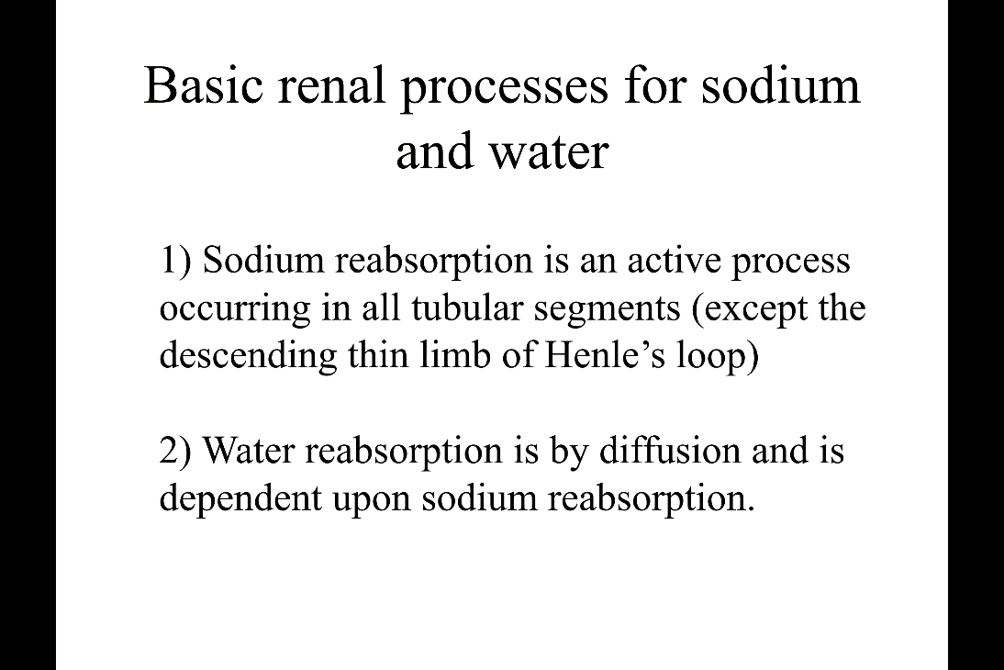
- At the time, reaches the distal part. The quantity is less, but very delicate regulation occurs.
Sodium and water reabsorption is tightly connected. They affect each other, but they move by different mechanism.
- Sodium reabsorption is active (require ATP) happen in all tubular segment (except :the descending thins limb of Henle’s loop, this is the hair pin structure that folds the proximal tubules. First part is going down to the medulla, and this part is very thin. This part is called descending thin limb of henle’s loop(usually called descending limb). This is the only part no active sodium reabsorption.)
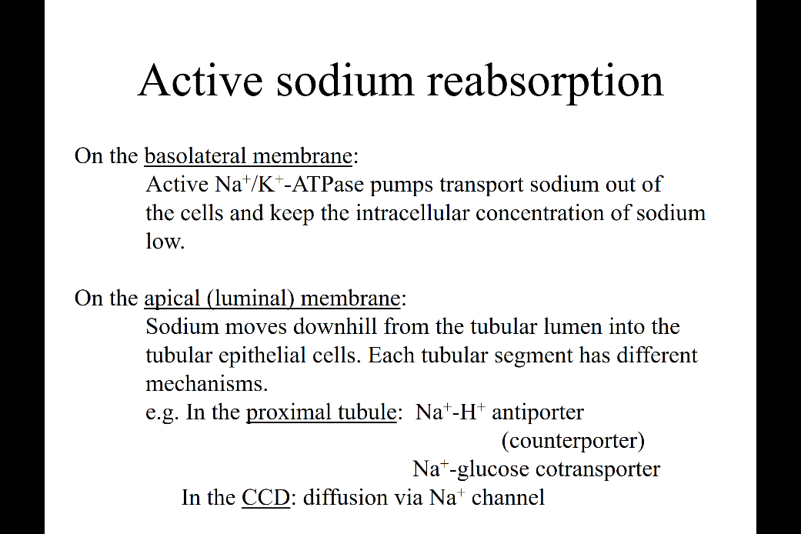
- Water reabsorption is by diffusion, so it flow by the chemical gradient generate by the sodium reabsorption. But! The way water is reabsorb in each tubular segment varies a lot.

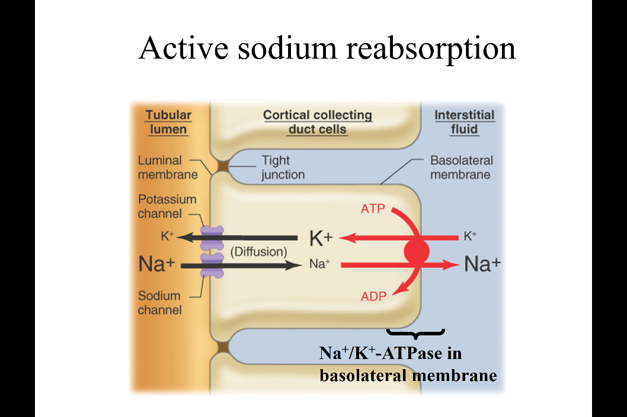
Active sodium reabsorption
- The tubular lumen + tubular epithelial cell + interstitial fluid
- This epithelial cell is cortical collecting duct cell (when talk about sodium reabsorption, always think of where it is happening, because depend on where in the tubule, different things are happening) cortical collecting duct cell are most important segment where sodium reabsorption is regulated.
- NA/K+ ATPase pumps out sodium from the cell into the interstitial space, and pumps in the potassium, create a low sodium concentration.
- Na+ channel in the lumen. Due to the low concentration, Na+ flow in from the tubular lumen to the cell.
- Net flow: one sodium disappear in the lumen, and then one sodium appears in the interstitial space.
- The Na+ goes back to systemic circulation --- this process is Na+ reabsorption in the cortical collecting duct cell.
- Collecting duct cell is terminal part of the tubule and divide to two segment the part in the cortex (cortical collecting duct - CCD) and the final part into the medulla (medullary collecting duct)
- This is not important foe the movement but in exchange with Na+ reabsorption, K+ goes out in to the tubular lumen. (Potassium secretion, one potassium disappear from interstitial fluid and one appear to the tubular lumen.) this is potassium secretion.
- Na+ reabsorbed, K+ secreted.
- The way sodium input to the tubular cell can deferrer in different segment. In the tubular collecting duct, its always Na+ channel. Also remember At the proximal tubule (Na+/glucose transporter, Na+ /H+ antipolar transporter ….many trans porter allow the sodium comes in to the cell….
- CCD has Na+ channels. Depend on the portion transporter can varies.
Renal sodium regulation
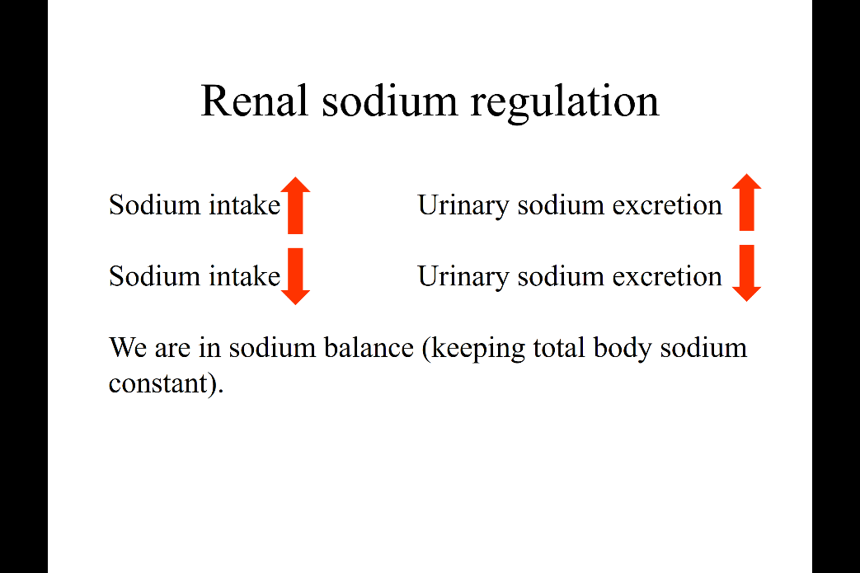
- Sodium intake increase, sodium excretion increase
- Sodium intake decrease, sodium excretion decrease.
- This is how body in sodium balance.
- The body has to sense how much sodium in the body, transfer this information to kidney. kidney can adjust the amount of Na+ excretion.
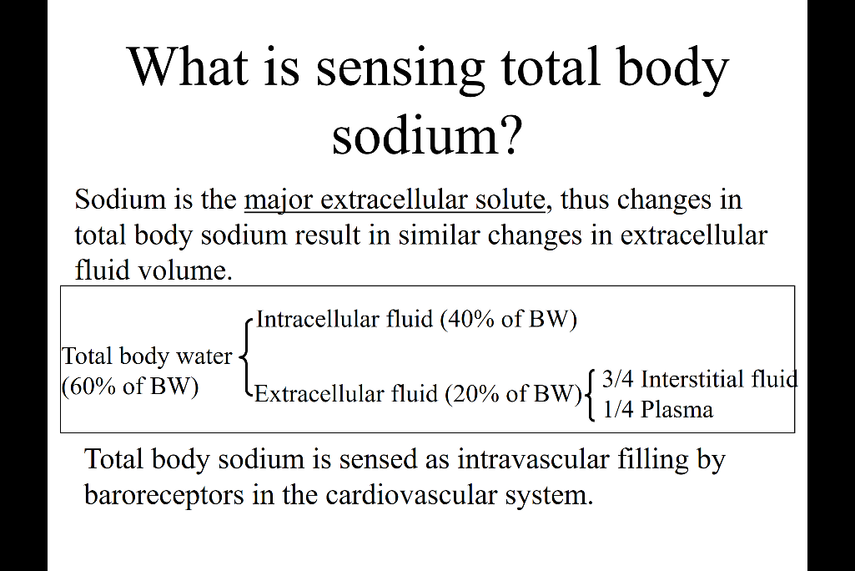
What is sensing the total body sodium --- there is no sensing in body but there is a replacement for this.
- Sodium is the major extracellular solute. The amount of sodium in the body is proportionate to the extracellular fluid volume. (this is a fact)
- So the body have the mechanism have the ability to sense extracellular fluid instead of sensing sodium amount.
The breakdown of body water
- 60% of body weight 40% intracellular (all the water in the cell), 20% extracellular fluid (plasma + interstitial fluid)
- Plasma is the only water that run around in the vessel. The body have a mechanism to sense that. The amount of plasma + RBC…that run as blood are sensed by baroreceptors
- Sense the effective plasma volume, to indirectly sensing the extracellular fluid volume. The baroreceptor has an important role to sense the total body sodium.
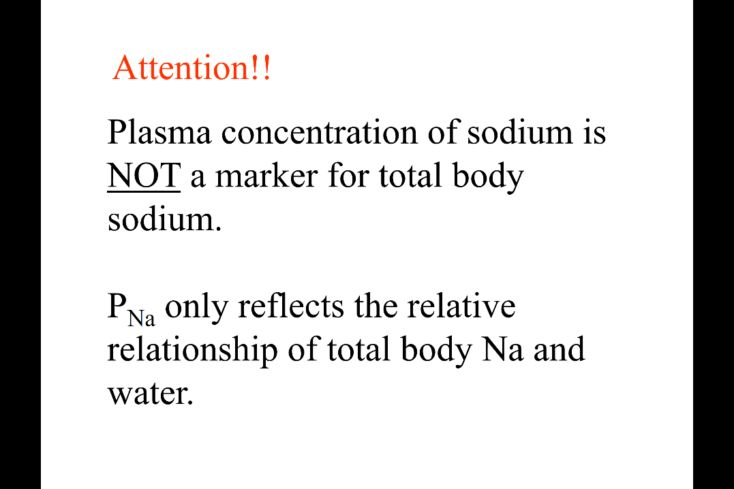
Attention!! The common error
- Plasma Na+ concentration is not a marker for sodium total volume in body. Concentration is the relative relationship.
- Na+ /water get sodium concentration but don’t tell how much Na+ there is in the body.
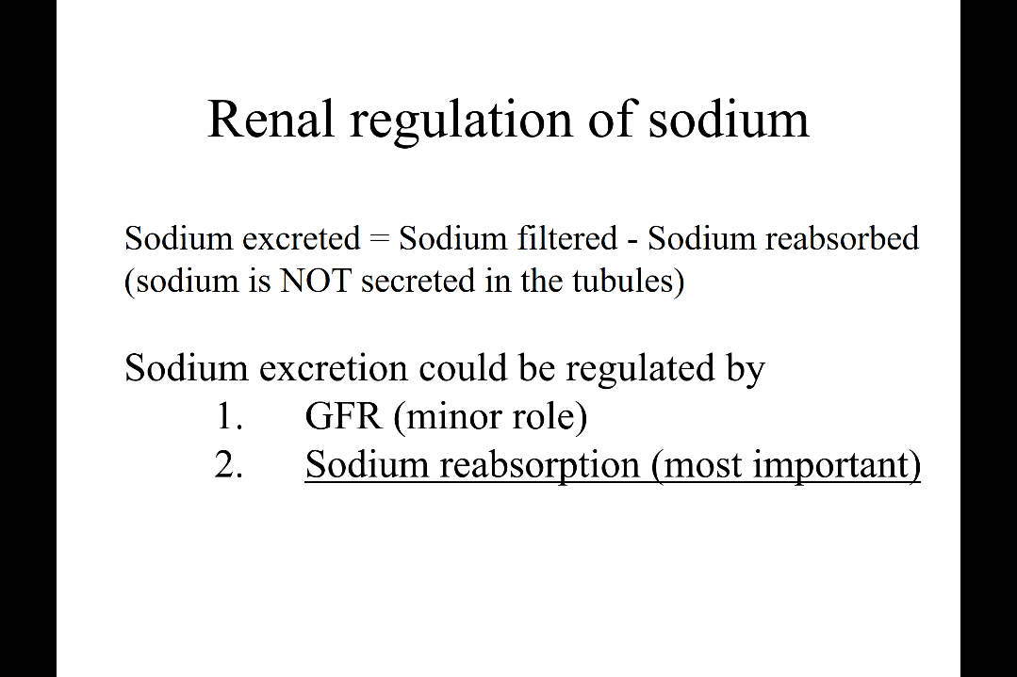
- So remember! That the Na+ concentration measured in plasma is not the total Sodium amount. (The cardiovascular need to sense the extracellular volume to sense the total amount of sodium in the body)

Now the kidney will react by adjusting the amount of sodium excretion in urine (2 factors – filter +reabsorb)
- The amount at the glomerulus (the filter flow) - the reabsorb
- The secretion part: sodium is not secreted.
- By adjusting GFR, reabsorption change the excretion
- But!! The regulation of GFR has a very minor role, most important is by sodium reabsorption adjustment.

How kidney adjust to the lost of sodium.
- Sodium and water lost due to diarrhea
- Sodium lost (with water in the form of diarrhea) decrease the plasma volume decrease venous pressure this sense by baroreceptor and activate the Renal sympathetic nerve.
- decrease venous pressure also lead to atrial pressure goes down, this is where another baroreceptor seats. Another signal tell renal sympathetic nerve to activate
- atrial pressure goes down diastolic volume decrease stroke volume decrease CO decrease arterial blood pressure decrease again sense by baroreceptor (sense by the one in high pressure system)
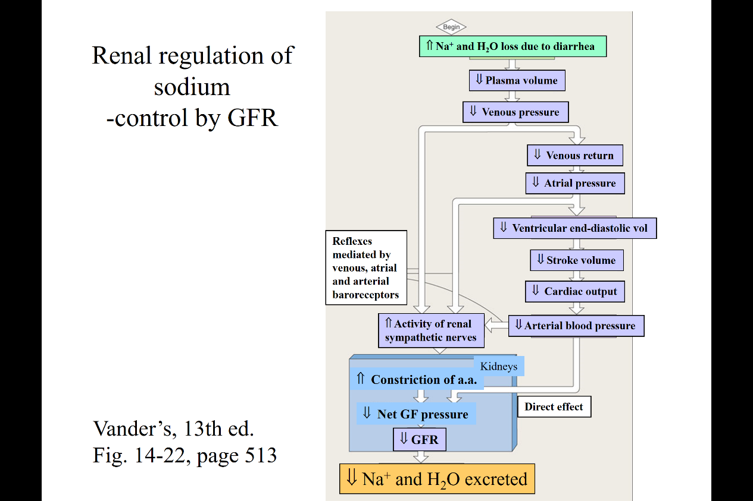
- all the top part tells you, the lost of extracellular fluid and sodium, all the baroreceptor in the venous system, atrium and high pressure system send signal to renal sympathetic nerve and activate
- activate sympathetic nerve, constriction of afferent arterial (last time we said if pinch the incoming flow into the glomerulus, the glomerulus filtration will decrease. Because interglomerular capillary pressure goes down) leads to decrease GFR decrease sodium, water excretion.
- The side arrow, if the arterial pressure goes down will have the direct effect on the glomerular filtration pressure as well. Just by decreasing the hydrostatic pressure in the capillary
- This chart has a very little role in the overall regulation of sodium.

Renal regulation of Na+
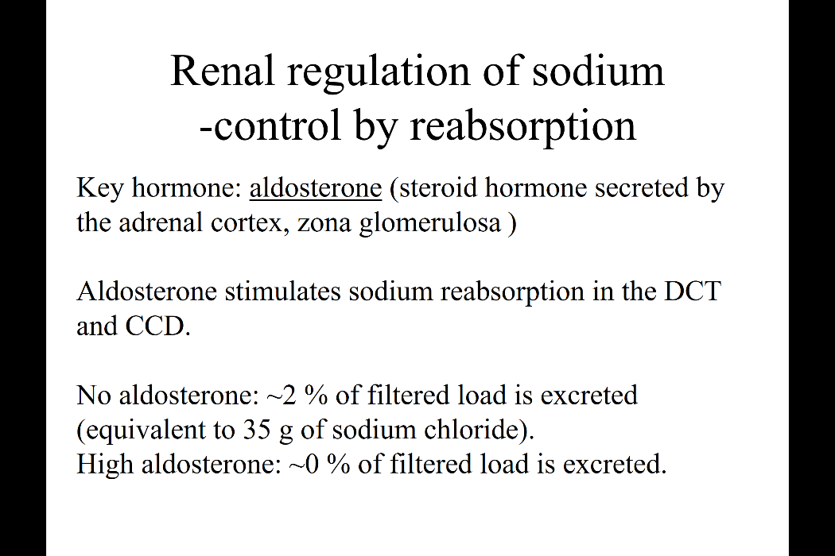
- Aldosterone is the most important hormone: this is a steroid hormone made by the adrenal cortex (made by adrenal gland but action in the kidney)
- Stimulate sodium reabsorption in DCT (distal convoluted tubule) and CCD (cortical collecting duct)

Sodium reabsorption occurs all along the tubule.
- In the proximal tubule reabsorb 2/3 of filter load.
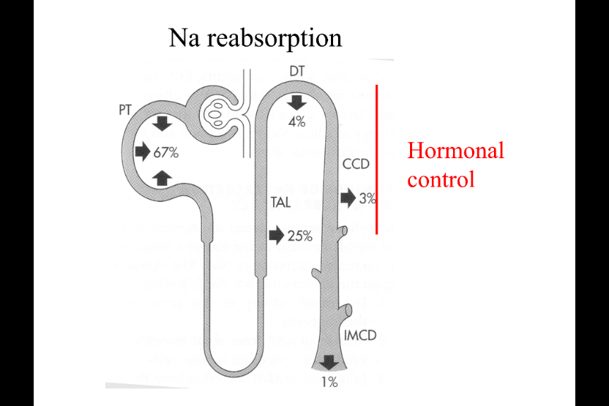
- Nothing is reabsorb at the descending limb of Henle’s
- Significant amount in thick ascending limb of Henle’s loop
- in distal convoluted and cortical collecting duct, small percentage but this is where the aldosterone play a critical role adjusting the amount of Na+ reabsorption
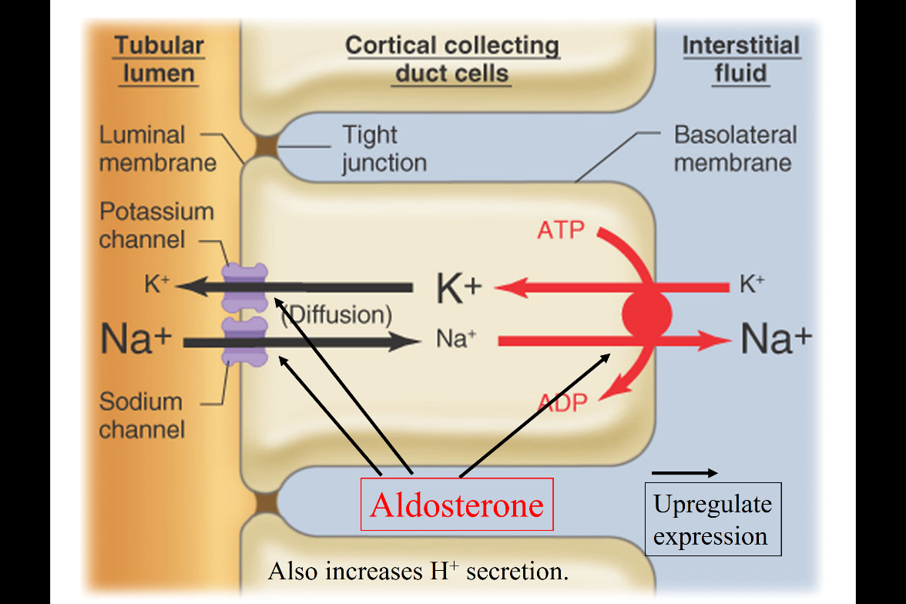
It really stimulate all the component needed for Na+ reabsorption, and upregulate the sodium, potassium ATPase on the basolateral membrane. It also upregulates the Na+ channel in the luminal membrane.
- K+ secretion also increase. H+ secretion increase (also the response of aldosterone)
- Aldosterone stimulate Na+ reabsorption, K+ secretion and H+ secretion
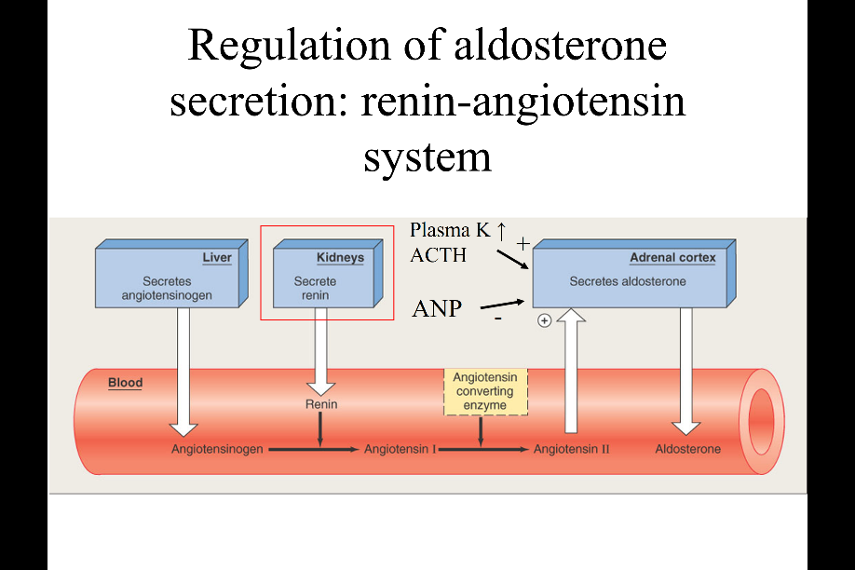
How does kidney regulate aldosterone?
- The link is in the cell that secret renin
- In the liver angiotensinogen is made, place in the blood convert to anginotensin1 by the enzyme renin (renin is the enzyme made by kidney plays an important role in sodium regulation and blood pressure) angiotensin 2 by angiotensin converting enzyme (called: ACE) (this is a potent stimulator of aldosterone secretion in the adrenal gland.
- This is how kidney contribute to aldosterone secretion
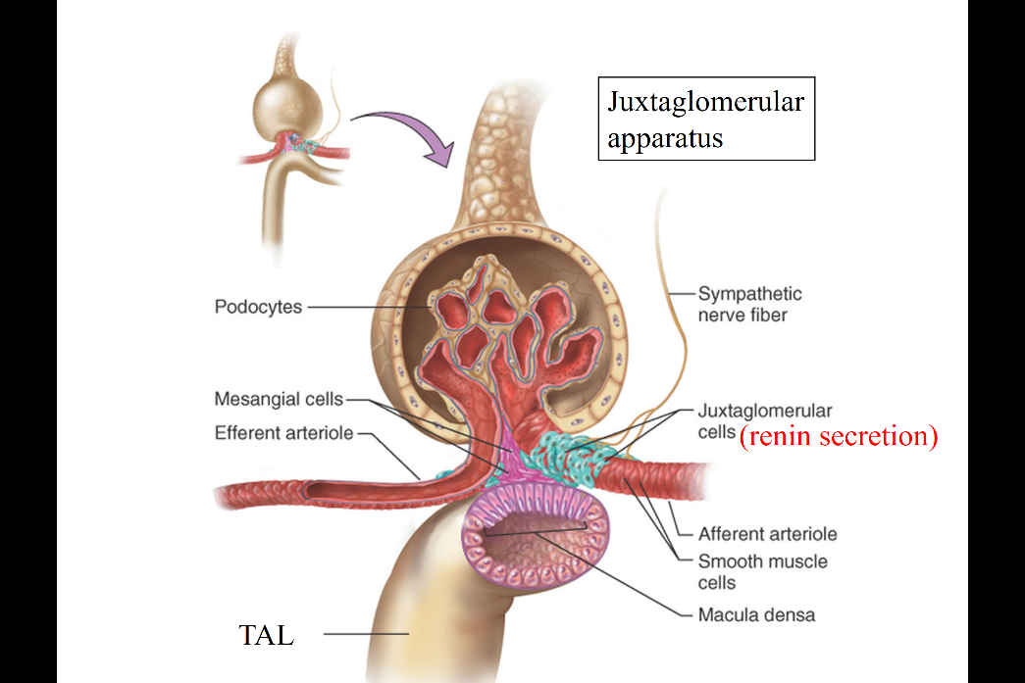
- Additional factors that stimulate : K+, ACTH also stimulate aldosterone. ANP inhibit aldosterone secretion.

Where in the kidney is renin made?
- Juxtaglomerular apparats (juxta means next to)
- Afferent is on the right then efferent
- Bellow is the thick ascending limb of Henle that came back from medulla and touch the originating glomerulus.
- Tall epithelial cell (on the pick) is the called Macula densa cells.
- Juxtaglomerular apparats refers to: the triangle region ----triangle area surrounding by: afferent arterial, efferent arterial, macula densa cell.
- The green cell are juxtaglomerular cell (or called renin secretin cell).
- This cell secret renin upon 3 stimuli:
1) sympathetic nerves (where the GFR chart become important, all the stimuli from baroreceptor contribute the activation of sympathetic nerve.)
2) the tension and filling of the afferent arterial
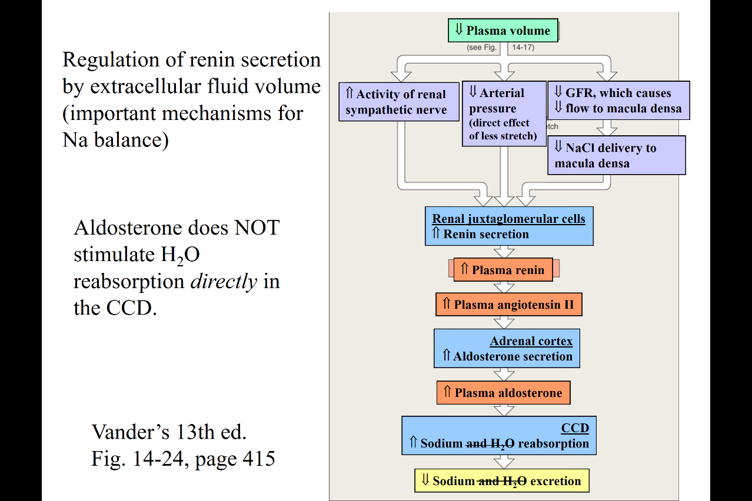
3) the tubular lumen (macula densa cell)

Regulate of aldosterone to Na+ , H2o during the volume depletion
- Low volume, activity of sympathetic nerve (previous chart) goes up
- Arterial pressure goes down due to the plasma volume --- direct impact on the filling of afferent arterial
- GFR goes down ( less water and solute are filtered to the glomerulus ; less fluid and solute are deliver to the macula densa cell. )
- All 3 pathway stimulate the renin secreting cell in the juxtaglomerular apparatus
- Renin increase
- Angiotensin 2 increase, which stimulate the aldosterone secretion from the adrenal gland
- Increase aldosterone
- Stimulate Na+ reabsorption at Cortical collecting duct mainly, and a little at distal convoluting tubule.
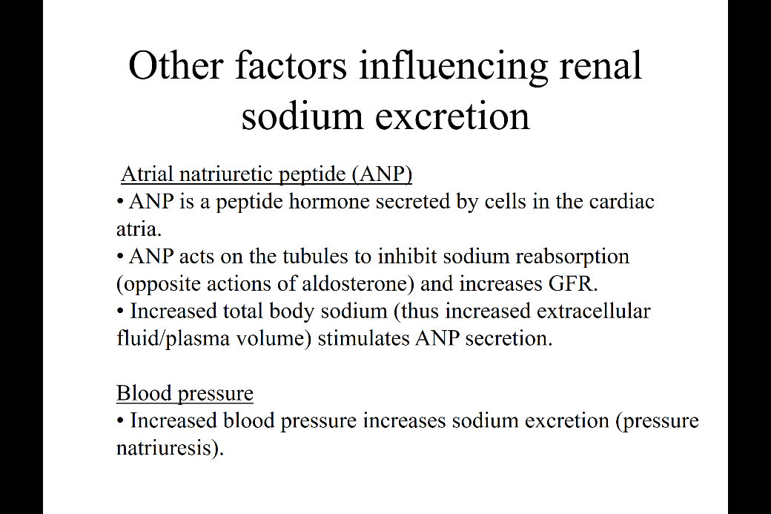
- Clarification: In chart, Na+ and water reabsorption are increases. But! What response to aldosterone is sodium reabsorption. Water reabsorption are increase eventually ( not the direct action of aldosterone)
Other factors:
- ANP, it’s a peptide hormone, secret by cardiac atria in response the distension of atrium. (response to volume expansion)
- Act on tubule to inhibit the sodium reabsorption (and increase the GFR) sodium excretes (opposite of aldosterone)
- Aldosterone is the retainer of sodium, but ANP is the eliminator of sodium
- Blood pressure (pressure natriuresis): this one doesn’t apply to physiological condition. (when have a extremely high blood pressure can contribute to sodium excretion)
ANP action
- Secret ANP in response to volume increase sense by cardiac atria distension
- Increase ANP will first inhibit aldosterone (in adrenal gland)
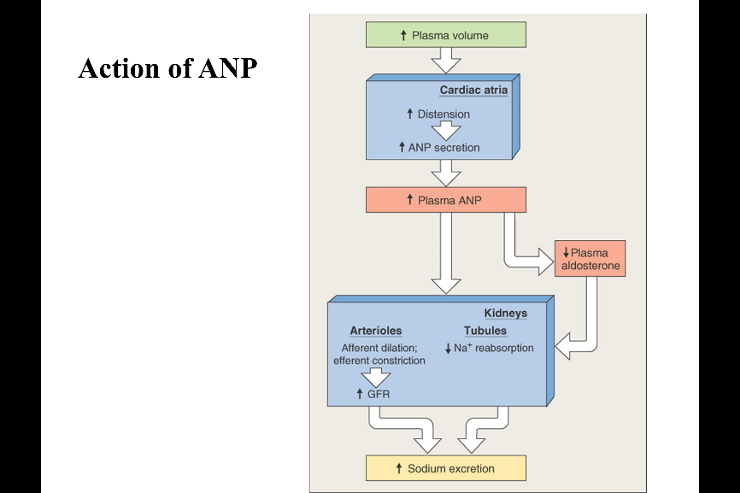
- In the kidney, relax the afferent arterial increase the GFR
- Inhibit sodium reabsorption in the tubule
- Both of the two contribute to sodium excretion in the urine
Aldosterone and ANp are plating opposite rule to keep the total amount of Sodium in body constant

